Joshua Herrick
CSD-310
Module 1.2 Assignment

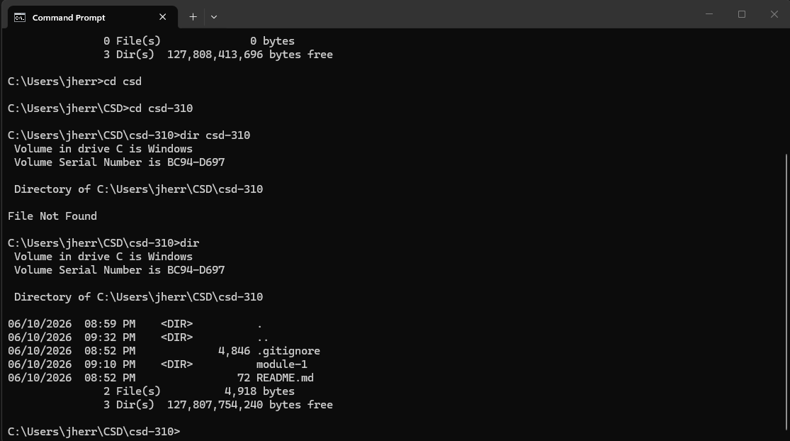

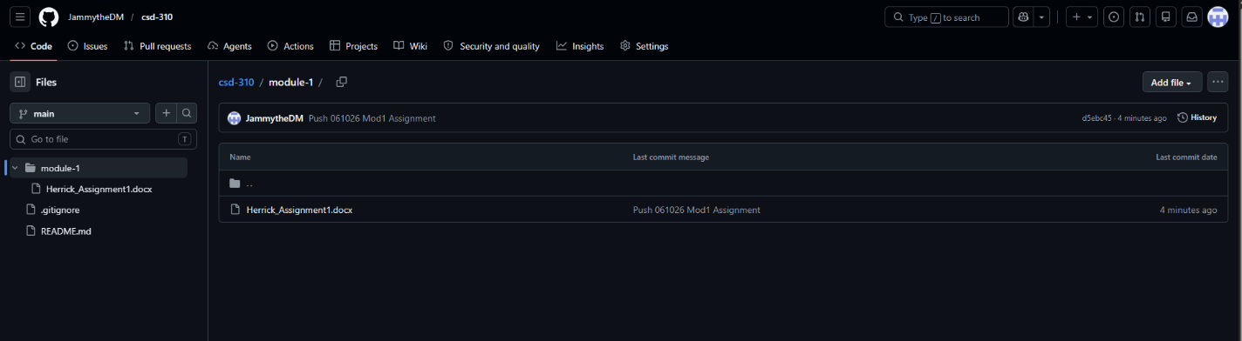

https://github.com/JammytheDM/csd-310.git

